Table for users:
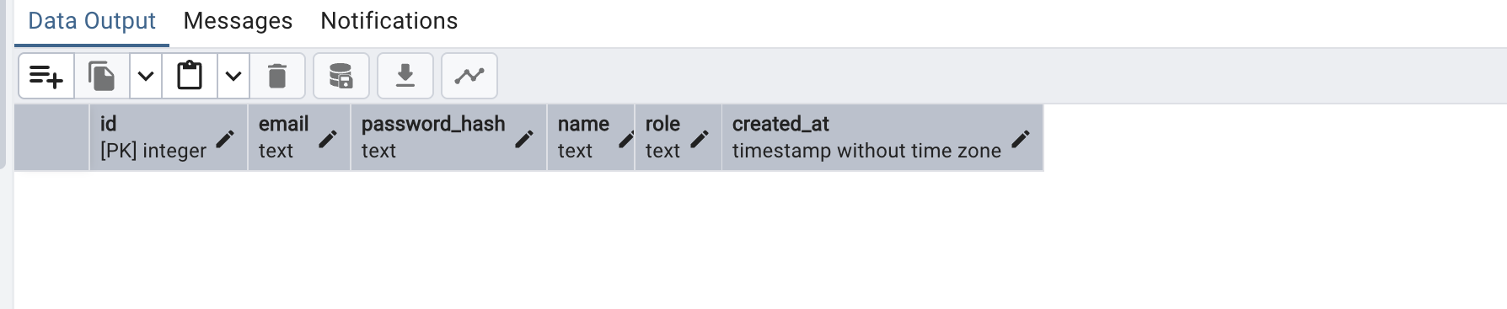
Table for orders:
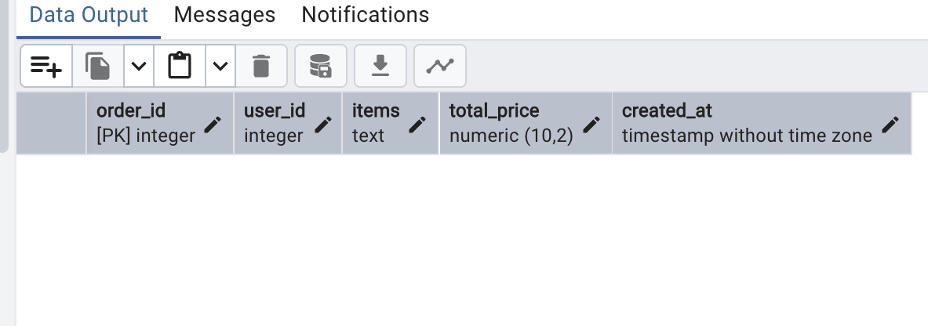
Table for products:
